* **Lab Task 2**

1. **Display the Airline Name with the first letter in uppercase and all other letters in lowercase, along with the length of the Airline Name for specific letters.**

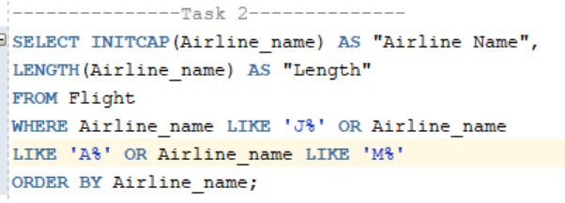

Output:

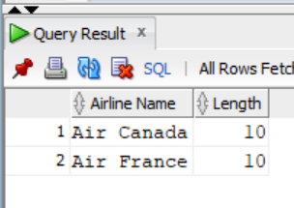

1. **To prompt the user for input:**

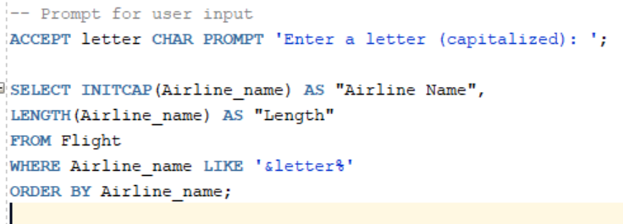

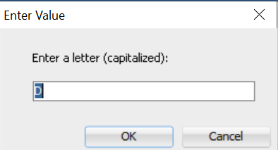Output:

